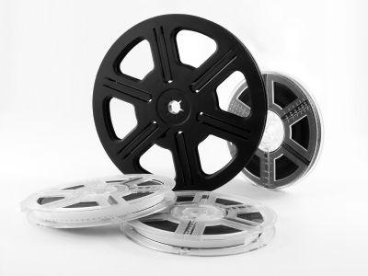
1st Quarter Project

Components of the project:
- Come up with a question (hypothesis) relating to the motion of an object that you can test by filming the object. The hypothesis should be creative and not just something like, “I wonder how fast I can run...”
- Film a video.
- Gather data from the video using ImageJ
(http://www.champaignschools.org/staffwebsites/hooperja/courses/546/links.php).
- Analyze and display your data using Excel.
- Write a report detailing your experiment and your findings. Use the new lab grading rubric (see the reverse side of this sheet) as your guide.

You may work in groups of 2-4. No exceptions. Group members may come from other physics sections, as long as the section is Mr. Hooper's.

Due Date: ____________________
Note: If you do not have access to a video camera, you may film your video at school.
Lab Report Grading Rubric (100 points)

- Cover Page
  - Displays lab report title, author(s), date of publication (i.e. the date submitted)
_____ /10
  - Abstract
    - Provides a brief overview of the lab, the skills/information learned, and some future applications to real life situations.
- Introduction
  - Includes a brief overview of the scientific concepts discussed in the lab and how they relate to the experiment.
_____ /10
  - Illustrates an accurate and thorough understanding of scientific concepts underlying the lab.
- Experimental design
  - The hypothesis is stated.
_____ /15
  - Adequate description is provided for all parts of the experiment. The reader would be able to replicate the experiment based on the description of the experimental design.
  - The experimental design, as described, is a well well-constructed test of the stated hypothesis.
- Results
  - The actual data taken during the experiment is well displayed and accurately labeled.
_____ /15
  - Relevant calculations are accurate, neatly presented, and labeled correctly.
  - When appropriate, sample calculations are shown.
  - When appropriate, data is displayed and labeled correctly in a graph.
- Error analysis
  - Relevant sources of potential error are identified.
_____ /10
  - The possible effects of sources of errors are discussed.
  - Ways to reduce errors are discussed.
- Discussion
  - The relationship between the variables is discussed and trends/patterns are logically analyzed. (I.e. was there a linear relationship between the variables? Were you able to find an equation that relates the variables?)
_____ /15
  - Discusses whether or not the results provide evidence in support of the hypothesis.
  - Predictions are made about what might happen if part of the lab were changed or how the experimental design could be changed.
- Conclusion
  - Includes whether the findings supported the hypothesis.
_____ /10
  - The most significant sources of error are discussed.
  - Identifies what was learned from the experiment.
- Neatness and Organization
  - Lab report is typed and has a professional appearance.
_____ /15
  - Lab report includes headings identifying each section.
  - Report uses correct spelling and grammar.

Video and ImageJ Instructions
- Film your video.
  - Make sure you have an object in the background (in at least one frame) that you can identify the height or width of.
  - Most video cameras compress the video. ImageJ requires that the video be uncompressed. A good way (on a PC) to uncompress your video is using a program called VirtualDub. (Go to portableapps.com and download VirtualDub.)
  - Open up your video in VirtualDub.
    - In the pull-down menus at the top of the screen, choose “Video” and then “Compression”. Make sure the uncompressed option is selected.
    - In order to make the output filesize smaller, choose the “Audio” pull-down menu and select “No Audio”.
    - You can use the tools at the bottom of the screen to crop your video to include only the frames you want in order to make the filesize as small as possible of the output video.
- You can download imageJ from the course website (mrhooper.net).
  - Navigate to the physics page, and click on the “links” button.
  - Download imageJ to your computer. The program is in a compressed “zip” file. PC's and Mac's should be able to “unzip” the file to a folder.
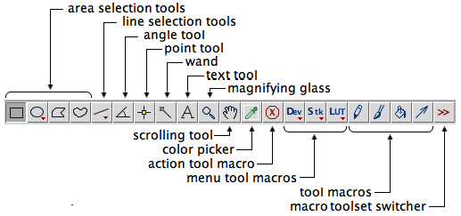
- Open the imageJ folder that you downloaded. Double-click on ij.jar to open the program.
- In the program, click on File⇨Open and navigate to your uncompressed video.
- Set up the point selection tool by clicking on Edit⇨Options⇨Point Tool and check the box that says “Auto-Next Slice”
- Double check that the program is calling “up” positive by going to Analyze⇨Set Measurements and verify that the box labeled “Invert Y Coordinates” is checked.
- In order for measurements to actually mean something, we need to set the scale. Click on the line selection tool (see graphic above), and draw a line that exactly spans the length of some known object (i.e. a meter stick, etc.). Then click on Analyze⇨Set scale. Enter the known distance represented by the line into the correct box and hit OK.
- In the screen that has the video, there is a slider bar at the bottom that allows you to go navigate through the video. Navigate to a place in the video where you want to start analyzing motion.
- Click on the “point tool” in the toolbar menu (see graphic above). Choose some point on the object (I recommend the very top and in the center), and click on it. You should see a “results” box pop up. This gives you the coordinates of the point. Every time you click, it will measure the coordinates of the point and store the data in a table as well as advance one-frame in the video.
- Continue clicking, going frame-by-frame, until you reach the end of the motion you wish to analyze.
- In your results table, select all of the data, and open up Excel. Paste the data into excel. Leave the first row blank for column headings. In ImageJ, the first column represents the frame#. The second column represents horizontal distance. The third column represents vertical distance (i.e. height).
- You'll need to identify the frame-rate of your video. Most likely it is either 15 or 30. You can convert the frame numbers to time by dividing each frame number by the frame rate. Note: You can have Excel do this calculation for you in a new column.
- Use Excel to make a chart, if appropriate.

